Tasks
Subjective Questions:

1. If there is an investment, should it be used to hire more IT agents, improve training programs, or upgrade ticket management software?
Approach: -
• Hire more IT agents: Here we compare count of Tickets, Average resolution time, and Average Satisfaction rate along with agent Id to evaluate current performance for agent in ticket handling.
• Improve training programs: Here we compare Average satisfaction rate and Average resolution time with each agent to evaluate week agents which have lower satisfaction rate and higher ticket resolution time with help of pivot table.
• Upgrade ticket management software: Here we compare priority vs ticket severity to understand efficiency of ticket management software system and identify if there is need for improvement.

1.Hire more IT agents Pivots Table:
2.Improve training programs Pivots Table:

3.Upgrade ticket management software Pivots Table & chart:
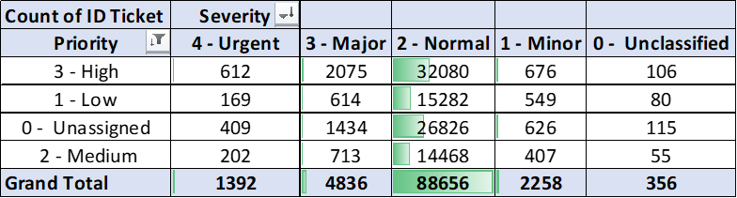

Insights:
- Hire more IT agents:
23 agents handled a high-ticket volume (1,960–2,021 tickets), while 27 agents handled significantly fewer tickets (1,889–1,950), indicating an uneven workload distribution across the team.

16 agents have an average satisfaction rate below 4.0, likely due to excessive workloads leading to longer resolution times and reduced service quality.

28 agents have an average resolution time exceeding 4.5 days, further emphasizing the strain on current staff.
• Improve training programs:
16 agents have a satisfaction rate below 4.0 and an average resolution time exceeding 4.5 days. This means that approximately 32% of the support team is underperforming and would benefit from targeted training programs.
• Upgrade ticket management software (Priority vs Severity):
Here Out of 97,498 total tickets, 29,410 (30.16%) are unassigned — indicating software limitations and possible skill gaps in the support team.
A large number of major severity tickets are incorrectly marked with normal priority, and 26,826 of these remain unassigned, exposing a workflow gap.
In the major severity category, only 43% are marked high priority, and 30% are still unassigned — highlighting issues in ticket triage and agent allocation.
Recommendations:
- Hire additional IT agents to balance ticket workload and reduce resolution times.

- Implement targeted training programs for the 32% underperforming agents to improve satisfaction and efficiency.
- Upgrade the ticket management system to ensure accurate prioritization and assignment of high-severity tickets.

2.Which agents need additional training based on their performance metrics?
Approach:
- Here, we compare the average satisfaction rate and average resolution time along with agent IDs to evaluate performance metrics and identify underperforming agents who may require special training.

Pivot Table:

Insights:
- 16 agents have a satisfaction rate below 4.0 and an average resolution time exceeding 4.5 days. This means that approximately 32% of the support team is underperforming and would benefit from targeted training programs.
Recommendations:
- Provide specialized training to average-performing agents and track their performance metrics post-training to measure improvement.
- Implement targeted training programs for the 32% underperforming agents to improve satisfaction and efficiency.
3. Do certain categories of requests have longer resolution times?
Visualization:

0.3
5.2
6.6
7.6
0.0
1.0
2.0
3.0
4.0
5.0
6.0
7.0
8.0
9.0
Login Access
Software
System
Hardware
Resolution Time (Days)
Request Type
Request category Vs Resolution Time

Insights:
- Hardware, System, Software regarding IT requests have longer resolution time.
- Login Access takes least resolution time.
Recommendations:
- Make an investment on Hardware, System and Software on IT Ticket management system so resolve requested tickets in lesser time.

4.How effective are the current software tools in managing IT tickets?
Visualization:

Insights:
- Priority vs Severity:
Analysis of the Priority vs Severity chart reveals that approximately 30% of tickets remain unassigned. This indicates a clear workflow gap within the ticket management system and highlights potential skill gaps among support agents.
- Satisfaction Rate by Year:
The graph shows a gradual improvement in employee satisfaction over the years. However, the increase is modest—from an average satisfaction rate of 3.98 in 2016 to 4.16 in 2020, reflecting only a 4.25% increase over five years.
- Resolution Time by Year:
The line graph indicates a slight yearly increase in ticket resolution time, suggesting inefficiencies in the current software system. In 2016, the average resolution time was 4.55 days, which rose to 4.59 days by 2020.
- According to above comparison charts ticket management software overall performance dropped by 30%
Recommendations:
• Upgrade the ticket management software to improve its capacity for handling a higher volume of tickets efficiently.
• Simplify and optimize the user interface for agents to enable faster ticket resolution and improve overall productivity.

5.How has the performance of the IT support team changed over time (e.g., monthly or quarterly)?
Visualization:

Insights:
- Satisfaction Rate by Year:
The graph shows a gradual improvement in employee satisfaction over the years. However, the increase is modest—from an average satisfaction rate of 3.98 in 2016 to 4.16 in 2020, reflecting only a 4.25% increase over five years.
- Resolution Time by Year:
The line graph indicates a slight yearly increase in ticket resolution time, suggesting inefficiencies in the current software system. In 2016, the average resolution time was 4.55 days, which rose to 4.59 days by 2020.
- Count of Ticket IDs by Year:
The number of tickets has steadily increased each year. In 2016, the total number of tickets was 13,051, rising to 29,088 by 2020—an overall increase of 122.8% over five years.
• Category-wise Tickets by Year:
The chart clearly shows a year-on-year increase in ticket volume across all categories. The highest growth was observed in the Hardware category, which increased from 1,272 tickets in 2016 to 2,933 tickets in 2020—an increase of 1,661 tickets or 130.5%.
The lowest growth was seen in the Login Access and System category, with a 121.5% increase over the same period.

Recommendations:
• The significant increase in the number of tickets over the past five years has led to a slight rise in ticket resolution time. This suggests a growing workload on the support team. To address this, additional hiring and regular training of agents are recommended to reduce the burden and maintain service efficiency.

• Upgrading the ticket management system, including hardware and infrastructure, will help reduce resolution times and is expected to improve employee satisfaction in the coming years.

6.If we invest more on tech (Hardware, software, etc), do you think it will improve the ticket resolution times and employee satisfaction?
Visualization:

Insights:
• Satisfaction Rate by Request Category:
Based on the bar chart, it is observed that hardware and software tickets have the lowest customer satisfaction scores compared to other categories.

• Distribution of Tickets Based on Resolution Time:
The chart clearly shows that the number of tickets drops significantly as resolution time increases. Notably, a one-day increase in resolution time results in a 37% decrease in
the number of resolved tickets, indicating the impact of resolution speed on ticket volume and possibly customer satisfaction.
Recommendations:
• Investing more in hardware and software infrastructure will directly contribute to improved ticket resolution times and higher employee satisfaction rates.

7.What are the key performance metrics for IT agents, and how can they be improved, do we need to fire any agents?
Visualization:

Insights:
• Key Performance Metrics:
The performance of IT agents can be evaluated using key metrics such as the number of tickets handled, customer satisfaction rate, and average resolution time.
• Performance Metrics of IT Agents:
By comparing the average resolution time and average satisfaction score alongside agent IDs, we gain a clear overview of each agent’s performance.
• Performance Insights:
Using sorting and filtering, we identified the five agents who may require targeted training to enhance their performance.
Agent ID 3 has the lowest satisfaction rate and the highest average ticket resolution time, indicating a need for performance improvement.

Recommendations:
• Performance-Based Action Plan:
By analyzing key performance metrics, we can identify average-performing agents. These agents should be enrolled in targeted training programs, and their progress should be tracked over time to measure improvement.
• Team Impact Consideration:
Terminating underperforming agents may increase the workload on the remaining team, potentially affecting overall efficiency and morale. Therefore, performance improvement should be prioritized before considering replacement.
• Mentorship Program:
Implement a mentorship program where top-performing agents’ mentor average performer. This approach allows for the sharing of best practices, encourages peer learning, and helps improve overall team performance.
8.How do employee demographics (e.g., department, seniority) impact satisfaction and ticket outcomes?
Visualization:

Insights:
• Average Resolution Time vs. Average Satisfaction Rate:
The bar chart shows a clear correlation: satisfaction rates are higher when resolution times are shorter.
The lowest satisfaction rate is 3.0, observed when the average resolution time is 21 days.
The highest satisfaction rate is 4.109, recorded when the average resolution time is less than 1 day.
• Distribution of Tickets by Age Group:
The column chart displays the distribution of tickets handled by different age groups. Using a group-by function, we identified:
The age group 44–46 handled the highest number of tickets (17,581).
The age group 47–49 handled the lowest number of tickets (3,885).
- Employee age group 29 – 46 handle 80.1% tickets and age group 47 – 55 handle 19.9% tickets

Recommendations:
Evaluate the lowest-performing agent based on the least number of tickets handled, highest resolution time, and lowest satisfaction score. Provide targeted training to address performance gaps, and monitor progress on a monthly and quarterly basis to ensure consistent improvement.
9. Identify the trends for IT support operations based on ticket volumes and satisfaction, and mention the peak and stable times?
Visualization:

25071
9277
6466
6200
4919
8789
7802
6582
4850
3899
0
5000
10000
15000
20000
25000
30000
0
1
2
3
4
5
6
7
8
10
Ticket Volume
Resolution Time (Days)
IT Support Operations Trends
ID Ticket
Count of Satisfaction Rate

Insights:
- Satisfaction Rate and Number of tickets will reduce when ticket resolution time increases
Resolution Time | Ticket  Volume | Satisfaction Score
Peak Hours  Resolution less than 72 Hours | 34384 | 4.1
Stable Time 4 – 16 days | 62302 | 4.0
Peak off More than 16 days | 812 | 4.3

Recommendations:
- Mostly 63.8% tickets lie under stable time and need to focus on improving resolution time.
- Increase hiring, Upgrade system technology.

10.What metrics should be included in the final dashboard to provide a comprehensive view of call centre performance and guide investment decisions?
Visualization: 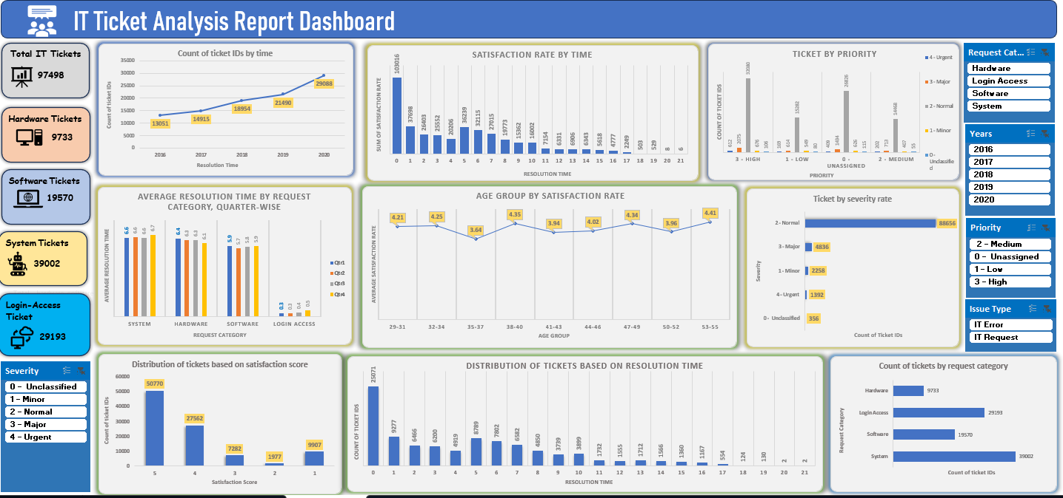

Insights:
- Count of Ticket IDs by Time: Count of ticket IDs by timeline graph gives us a detailed overview of the distribution of ticket IDs by year.
- Satisfaction Rate by Time: Satisfaction rate by time shows how the satisfaction score will be impacted when resolution time increases. Here, we clearly observe that the satisfaction score will be maximum when resolution time is less than 24 hours.
- Tickets by Priority: Ticket by priority clustered column chart shows system inefficiencies, where the major segment of tickets is handled in the normal priority section.
- Average Resolution Time by Request Category (Quarterly): By this chart, we see which type of ticket requests take less or more time quarterly. Login access takes the least time, while system, hardware, and software take longer resolution times.
- Satisfaction Rate by Age Group: It helps to determine which age group performs well and which group’s satisfaction rate needs improvement.
- Ticket by Severity Rate: Ticket by severity rate helps to evaluate the ticket distribution based on severity rate in the ticket management system.
- Distribution of Ticket by Satisfaction Score: Ticket distribution based on received satisfaction rate by employees tells us the number of tickets with high scores and the number of tickets with low scores.
- Distribution of Tickets Based on Resolution Time: The chart clearly shows that the number of tickets drops significantly as resolution time increases. Notably, a one-day increase in resolution time results in a 37% decrease in the number of resolved tickets, indicating the impact of resolution speed on ticket volume and possibly employee satisfaction.
- Count of Ticket IDs by Request Category: From this column bar graph chart, we observed that the highest number of tickets raised by employees is in the system category (39,002 tickets), followed by login access (29,193 tickets), software (19,570 tickets), and the least in the hardware category (9,733 tickets).

Recommendations:
- Improve Resolution Time: Since satisfaction is highest when tickets are resolved within 24 hours, prioritize faster resolution through system upgradation, timely - training of average agents and better allocation of resources.
- Improve Priority Handling: A large share of tickets falls under “normal priority.” Improve prioritization rules to ensure critical issues get addressed quickly and avoid extra resolution time.
- Targeted Training by Age Group: Some age groups show lower satisfaction rates. Provide training and communication support can help improve user experience and satisfaction in these segments.
- Betterment Resource Allocation by Category & Severity: Since hardware/software issues take longer, provide skilled resources or create specialized task forces for complex categories and high-severity tickets.

